Name: Rushiraj Suwarnkar  
Roll no.: 381018  
PRN: 22310315  
———————————————————————————————

**Assignment 5: Implement Minimax Algorithm for Game Playing**  
———————————————————————————————

**Problem Statement:**  
Implement the Minimax algorithm to create an AI for a two-player game (such as Tic-Tac-Toe or Chess) that decides the optimal move by simulating all possible moves and assuming both players play optimally.  
———————————————————————————————

**Objectives:**

* Understand the working of the Minimax algorithm.
* Implement Minimax for decision-making in two-player games.
* Analyze the performance and outcomes of the AI.  
  ———————————————————————————————

**Theory:**  
———————————————————————————————

**Methodology:**  
The Minimax algorithm is a recursive strategy used in decision-making and game theory. It simulates all possible moves of both players to determine the optimal move. The algorithm assumes that the maximizing player tries to maximize the score while the minimizing player tries to minimize it. The optimal move is chosen based on the evaluation of the game tree.  
———————————————————————————————

**Working Principle / Algorithm:**  
———————————————————————————————

**Minimax Algorithm:**

1. Generate the complete game tree from the current state.
2. Evaluate terminal nodes using a heuristic evaluation function.
3. Recursively backpropagate values:
   * Maximizing player chooses the maximum value from child nodes.
   * Minimizing player chooses the minimum value from child nodes.
4. The root node chooses the move that leads to the optimal outcome for the current player.
5. Repeat this process for each turn until the game ends.  
   ———————————————————————————————

**Advantages:**

* Provides optimal decisions assuming both players play perfectly.
* Can be combined with pruning techniques (like Alpha-Beta) to improve efficiency.
* Widely applicable in turn-based, zero-sum games.  
  ———————————————————————————————

**Disadvantages / Limitations:**

* Computationally expensive for games with large search spaces.
* May require optimization (like Alpha-Beta pruning) for practical use in complex games.
* Assumes perfect play from both players, which may not reflect human behavior.  
  ———————————————————————————————

**Diagram:**

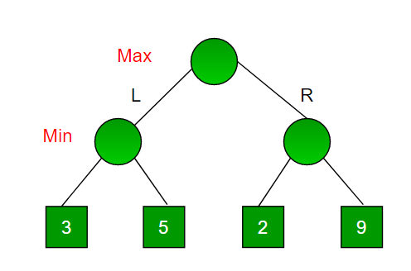  
———————————————————————————————

**Conclusion:**  
The Minimax algorithm is an essential technique in AI for game playing. It systematically evaluates possible moves to select the best strategy for the current player. With optimizations like Alpha-Beta pruning, it becomes practical for larger and more complex games.  
———————————————————————————————